WEBSITE LINK: https://subashvelug.github.io/Travel/
Defects:
1.Fav icon is missing.
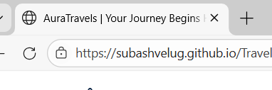
2.In light mode the Active state is not visible.
3.In home page1 on travel stories section the card image is missing.
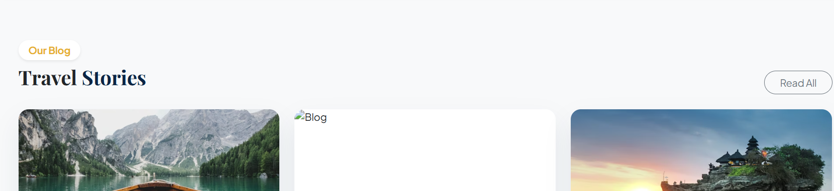
4.In light mode footer section the link should be highlighted when hover the text.
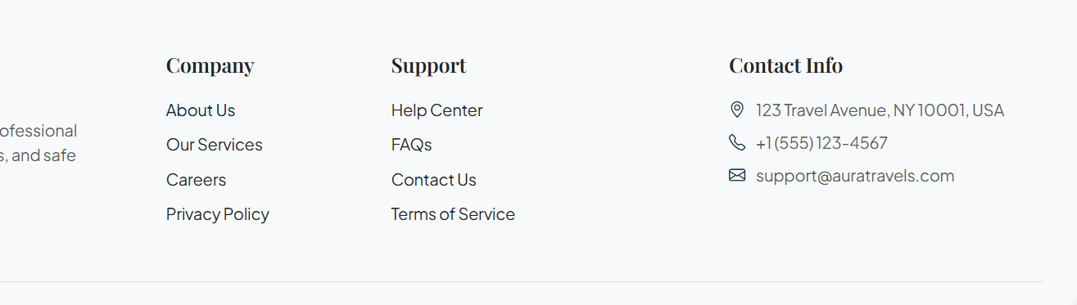
5.In light mode on homepage2 the text should be contrast in hero section.
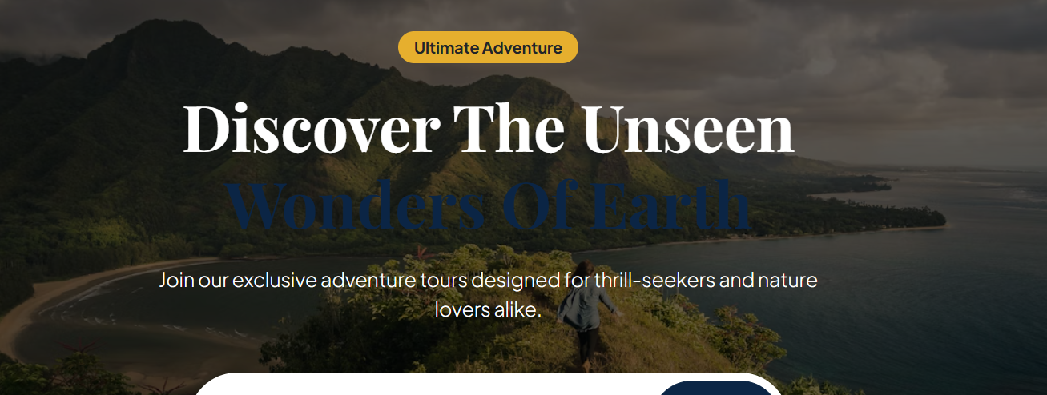
6.In home page2 on hero section the searchbox and button should be aligned.
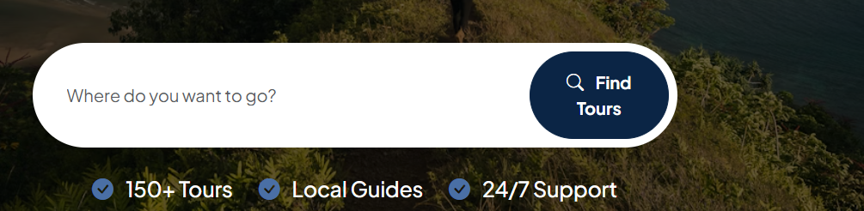
7.In about us page on our journey section the card should be aligned.
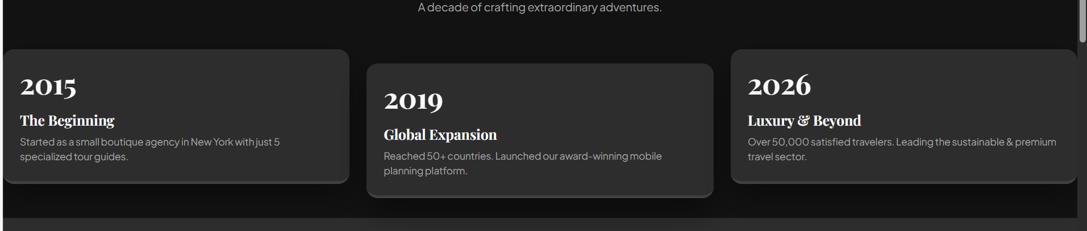
8.In about us page on eco friendly section the card should be aligned.
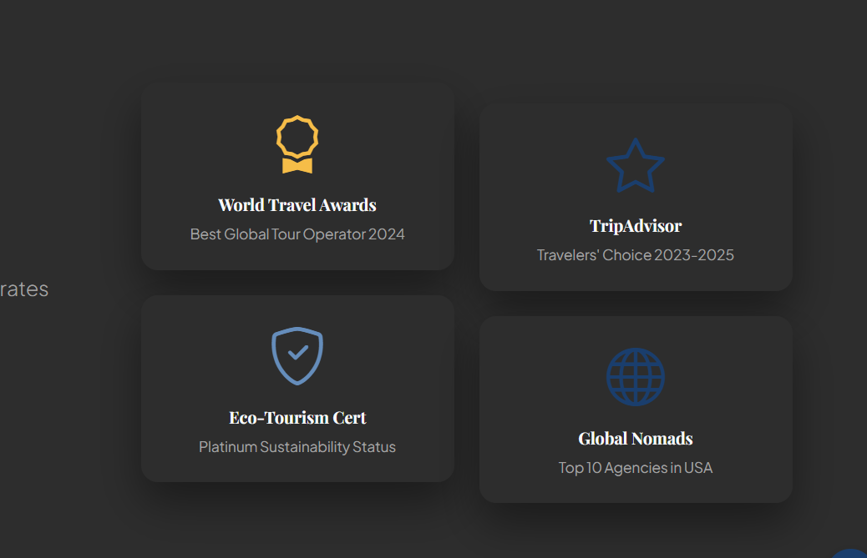
9.Contact page is missing. While clicking contact menu it goes to footer section.
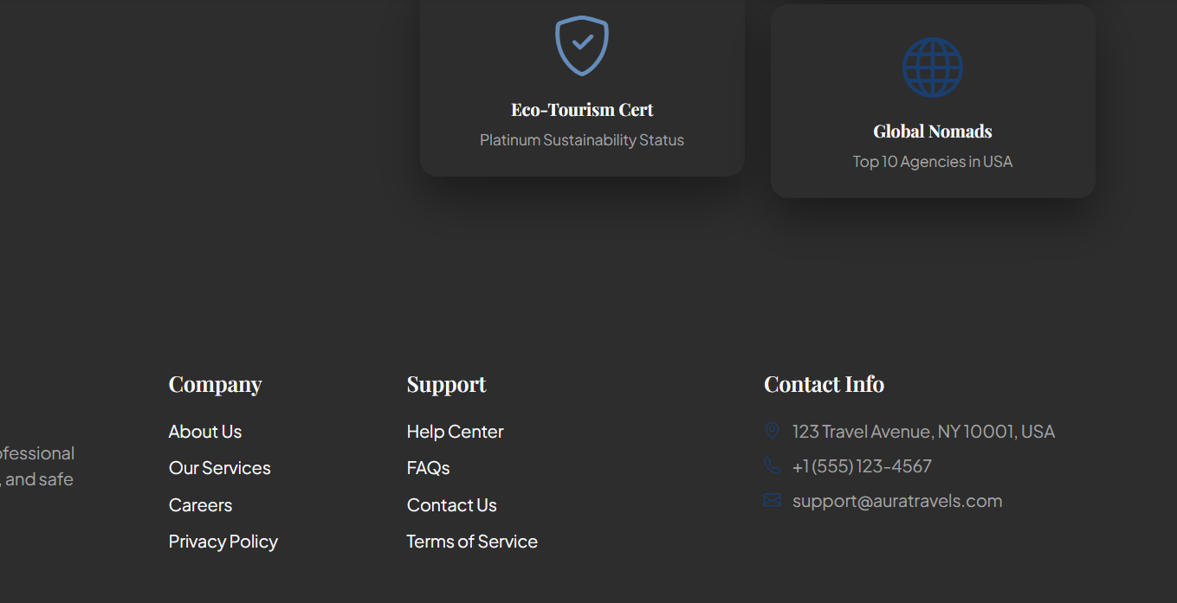
10.In login and signup page the nav bar should be removed.
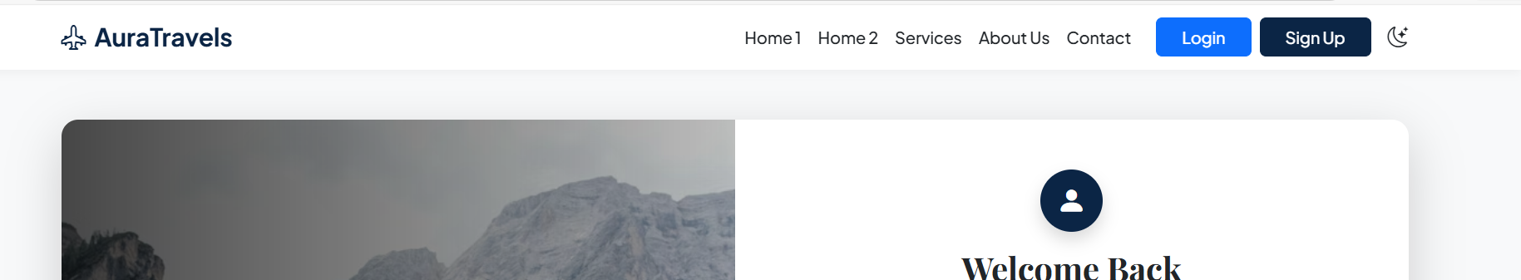
11.In login and signup page the brand logo should be in the card.
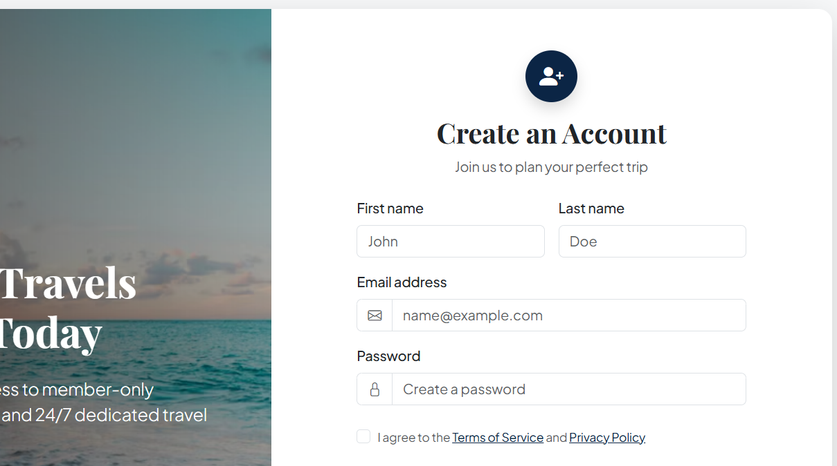
12.In signup page the link should be highlight when hovering.
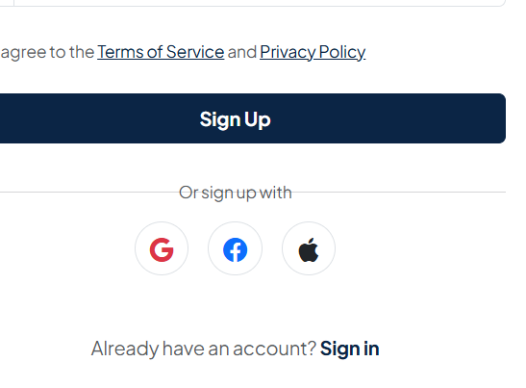
13.In login page the link should be highlighted when hover.
